9. TechSavvy, a leading retailer of electronic gadgets, has launched an online shopping platform with a wide range of products such as smartphones, laptops, tablets and accessories, grouped in categories for easy browsing. Key functionalities include user registration and login, product search and filtering, detailed product descriptions and reviews, secure payment options, and order tracking. Customers can add items to the cart, edit or remove them, check out, check order status and browse order history. Products are logically categorized with popular categories first, and all categories and subcategories are shown on the home page. The administrator can add new items, remove items, modify prices, update descriptions, and view information about each customer who checks out.
AIM
To design a simple Online Shopping webpage where customers can browse products by category, search items, check availability, add items to the shopping cart, edit or remove them, check out, and check the order status.
HTML CODE
<!DOCTYPE html>
<html lang="en">
<head>
<meta charset="UTF-8">
<meta name="viewport" content="width=device-width, initial-scale=1">
<title>TechSavvy Online Shopping</title>
<style>
body { font: 16px Arial, sans-serif; max-width: 650px; margin: 40px auto; padding: 20px; color: #222; background: #f4f6fb; }
h1 { color: #3d4fd1; }
section { border: 1px solid #d3d9f3; background: #fff; border-radius: 8px; padding: 20px; margin: 20px 0; }
input, select, button { padding: 10px; margin: 6px 0; width: 100%; box-sizing: border-box; }
button { background: #3d4fd1; color: #fff; border: 0; border-radius: 6px; cursor: pointer; }
.item { display: flex; justify-content: space-between; align-items: center; border-bottom: 1px solid #eee; padding: 8px 0; }
.item button { width: auto; margin: 0 0 0 8px; padding: 6px 12px; }
button:disabled { background: #aaa; cursor: not-allowed; }
.ok { color: #146c43; font-weight: bold; }
</style>
</head>
<body>
<h1>TechSavvy Gadgets</h1>

<section>
<h2>Browse Products</h2>
<select id="cat" onchange="showProducts()">
<option>All</option><option>Smartphones</option><option>Laptops</option>
<option>Tablets</option><option>Accessories</option>
</select>
<input id="q" placeholder="Search items..." oninput="showProducts()">
<div id="products"></div>
</section>

<section>
<h2>Shopping Cart</h2>
<div id="cart"></div>
<p><b>Total: Rs.<span id="total">0</span></b></p>
<button onclick="checkout()">Checkout</button>
<p id="orderResult"></p>
</section>

<section>
<h2>Order Status</h2>
<input id="oid" placeholder="Enter order ID" maxlength="6">
<button onclick="checkOrder()">Check Status</button>
<p id="statusResult"></p>
<small>Sample order ID: TS3001</small>
</section>

<script>
const products = [
{id: 1, name: "Galaxy S24 Phone", cat: "Smartphones", price: 59999, stock: 8},
{id: 2, name: "UltraBook Pro 14", cat: "Laptops", price: 74999, stock: 5},
{id: 3, name: "Tab Air 11", cat: "Tablets", price: 32999, stock: 0},
{id: 4, name: "Wireless Earbuds", cat: "Accessories", price: 2999, stock: 25}
];
let cart = {};
function showProducts() {
const c = document.getElementById("cat").value;
const q = document.getElementById("q").value.toLowerCase();
document.getElementById("products").innerHTML = products
.filter(p => (c === "All" || p.cat === c) && p.name.toLowerCase().includes(q))
.map(p => `<div class="item"><span><b>${p.name}</b><br>${p.cat} | Rs.${p.price} | ` +
(p.stock ? `In stock (${p.stock})` : "Out of stock") + `</span>` +
`<button ${p.stock ? "" : "disabled"} onclick="addItem(${p.id})">Add to Cart</button></div>`).join("");
}
function addItem(id) { cart[id] = (cart[id] || 0) + 1; showCart(); }
function changeQty(id, d) { cart[id] += d; if (cart[id] <= 0) delete cart[id]; showCart(); }
function showCart() {
let total = 0;
document.getElementById("cart").innerHTML = Object.keys(cart).length ? Object.keys(cart).map(id => {
const p = products.find(x => x.id == id); total += p.price * cart[id];
return `<div class="item"><span>${p.name} x ${cart[id]}</span><span>Rs.${p.price * cart[id]}
<button onclick="changeQty(${id},1)">+</button><button onclick="changeQty(${id},-1)">-</button></span></div>`;
}).join("") : "Cart is empty.";
document.getElementById("total").textContent = total;
}
function checkout() {
const out = document.getElementById("orderResult");
if (!Object.keys(cart).length) { out.textContent = "Add items before checkout."; return; }
out.className = "ok";
out.textContent = "Order placed successfully. Order ID: TS3001. Confirmation sent by e-mail.";
cart = {}; showCart();
}
function checkOrder() {
const id = document.getElementById("oid").value;
document.getElementById("statusResult").textContent = id === "TS3001"
? "Status: Shipped - expected delivery in 3 days" : "Order not found.";
}
showProducts(); showCart();
</script>
</body>
</html>

OUTPUT
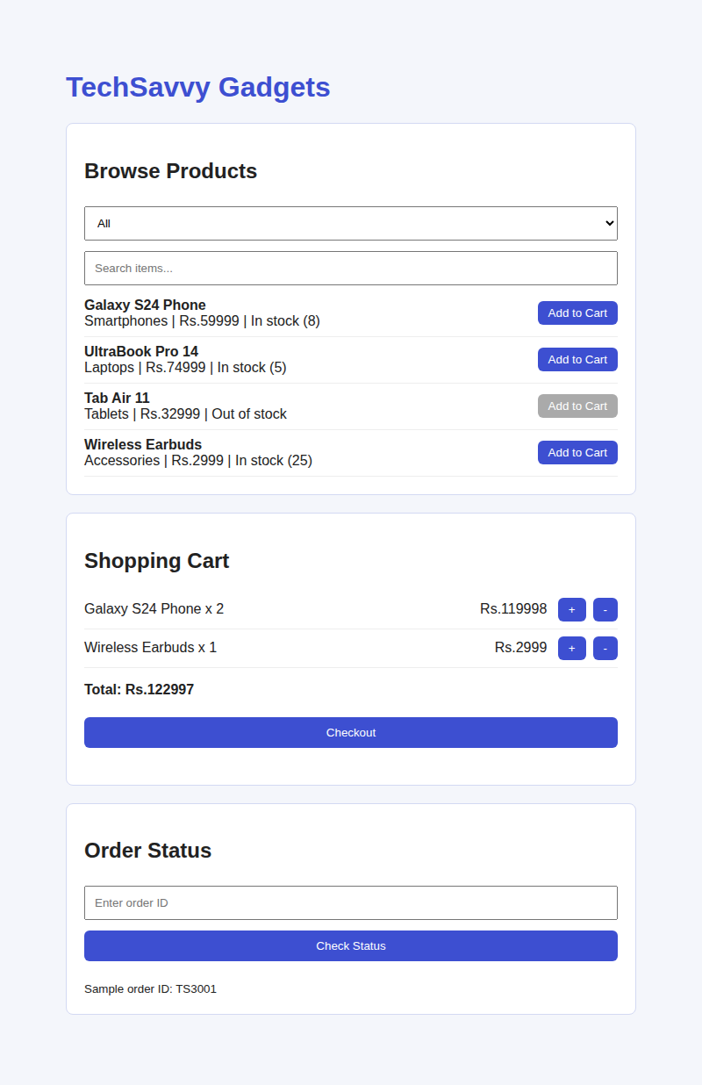  Output 1: Products listed and items added to cart | 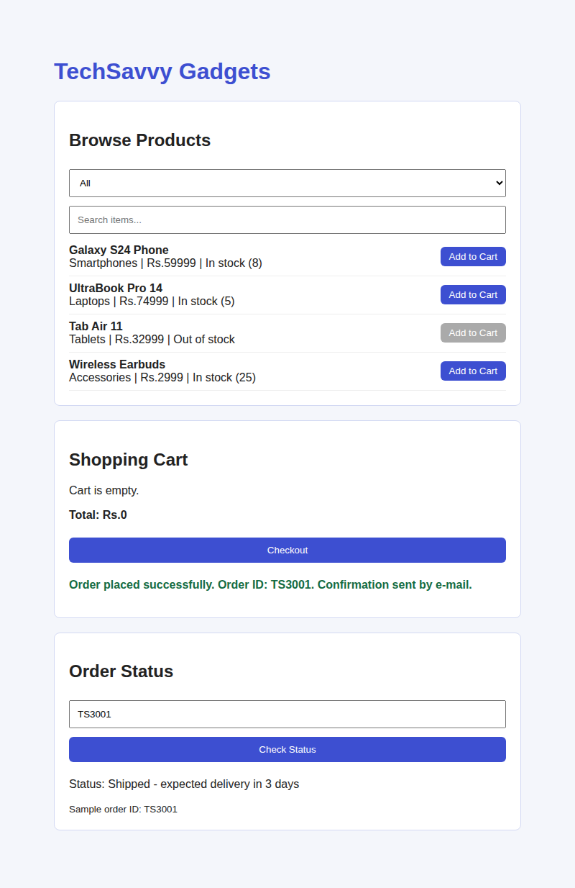  Output 2: Order placed and status checked
RESULT
The Online Shopping webpage was created successfully. It filters products by category and search text, shows stock availability, manages the shopping cart with quantity change and total, places an order with a confirmation message, and displays the status of the sample order ID TS3001.

